**Salesforce CRM Project Documentation**

**HandsMen Threads: Elevating the Art of  
Sophistication in Men's Fashion**

**Submitted by:  
KORAPALA ABHINAYASRI**

**Institution/Organization:  
SMART BRIDGE**

**Program:  
Salesforce Developer with Agentblazer Champion Program**

**Project Type:  
Salesforce CRM Implementation  
*(Custom Objects, Flows, Apex, Automation, Reports)***

**Guided by:  
Smart Bridge Educational Pvt. Lmt**

**Project Overview**

The HandsMen Threads project aims to redefine men's fashion by focusing on sophisticated, high-quality garments that blend traditional craftsmanship with contemporary style. Our goal is to elevate the male wardrobe beyond mere clothing, offering pieces that embody artistry, exclusivity, and lasting value. We will achieve this through meticulous design, premium material sourcing, and a commitment to tailoring excellence, providing discerning men with a unique and refined aesthetic that transcends fleeting trends.

**Objectives:**

* Centralize customer relationship and data tracking using Salesforce CRM.
* Employ automation through Salesforce Flows, Email Alerts, and Process Builders to streamline operations.
* Create a user-friendly admin dashboard to manage all business operations efficiently.
* Introduce loyalty-based reward functionality with tiered benefits to enhance customer retention.
* Design a scalable, modular architecture that supports future growth and third-party integrations.
* Ensure robust user data protection and compliance with international privacy standards.
* Implement comprehensive reporting and dashboards for real-time business monitoring and data-driven decisions.

**Key Features:**

* Visually appealing, responsive e-commerce design optimized for all devices.
* Seamless checkout process with multiple payment options.
* Comprehensive customer profiles including purchase history and preferences.
* Personalized email campaigns (e.g., welcome series, abandoned cart reminders).
* Unified administrator dashboard for sales, customer, and inventory management.
* Loyalty-based rewards program with tiered benefits.
* API-first architecture for seamless integration with third-party systems.
* Secure handling of sensitive customer and payment data (PCI DSS compliant).
* Adherence to international data privacy regulations (e.g., GDPR, CCPA).

**Target Users:**

The platform is built for sophisticated shoppers who expect personalization, quality, and seamless digital experiences in premium fashion.

**Technology Stack:**

**🔹Frontend:** Lightning Web Components (LWC)

**🔹Backend:** Salesforce Apex, Node.js

**🔹Database:** Salesforce Custom and Standard Objects

**🔹CRM & Automation:** Salesforce Flow, Email Alerts, Process Builder

**🔹Hosting:** Salesforce Experience Cloud / Web Hosting

**🔹Other Tools:** GitHub, VS Code, Figma, Rational Rose

**Core Project Objectives**

The HandsMen Threads project is dedicated to transforming men's fashion by offering sophisticated, high-quality garments that seamlessly blend traditional craftsmanship with contemporary style. Our core mission is to elevate the male wardrobe beyond mere clothing, providing pieces that embody artistry, exclusivity, and enduring value. We will achieve this through meticulous design, sourcing of premium materials, and an unwavering commitment to tailoring excellence, ultimately offering discerning men a unique and refined aesthetic that transcends fleeting trends.

1. **Redefine Men's Fashion Sophistication**

To establish a new benchmark for elegance and refinement in men's apparel, moving beyond mass-produced trends towards timeless, artisan-crafted pieces.

1. **Curate Exclusive Collections**

To design and produce limited-edition collections that highlight unique designs, superior materials, and exceptional tailoring, ensuring exclusivity for our clientele.

1. **Champion Quality and Craftsmanship**

To commit to the highest standards of production, utilizing premium fabrics and meticulous construction techniques that guarantee durability, comfort, and a luxurious feel.

1. **Cultivate Brand Recognition**

To build **HandsMen Threads** into a recognized and respected brand synonymous with high-end men's fashion, attracting a discerning customer base that values quality, artistry, and individuality.

1. **Ensure Customer Satisfaction**

To provide an unparalleled customer experience, from product selection to after-sales support, fostering loyalty and positive word-of-mouth.

1. **Establish a Strong Online Presence**

To develop a sophisticated and user-friendly e-commerce platform that showcases our collections beautifully and provides a seamless shopping experience for a global audience.

1. **Forge Strategic Partnerships**

To collaborate with renowned artisans, fashion influencers, and luxury retailers to enhance brand visibility and expand market reach.

1. **Implement Sustainable Practices**

To integrate environmentally conscious and ethical sourcing and production methods throughout our supply chain, appealing to socially responsible consumers.

1. **Drive Revenue Growth and Profitability**

To achieve sustainable financial growth through effective sales strategies, competitive pricing, and efficient operational management.

1. **Foster a Community of Discerning Clients**

To build a loyal community around the **HandsMen Threads** brand through exclusive events, personalized services, and engaging content that celebrates the art of men's sophistication.

**Scope 1: Software Requirements Specification**

**1. Purpose**

For the "HandsMen Threads" project, the purpose of Salesforce CRM is to be the central hub for all customer interactions, from initial engagement to post-purchase support. It will enable us to build deep, personalized relationships with our discerning clientele by providing a unified view of each customer, streamlining sales processes, enhancing customer service, and powering targeted marketing campaigns. Ultimately, Salesforce CRM will be the key technological enabler for delivering the elevated, sophisticated customer experience that defines the HandsMen Threads brand, fostering loyalty and driving sustainable growth.

**2. System Structure Overview**

HandsMen Threads operates on a comprehensive system designed to deliver sophisticated men's fashion. This system is composed of interconnected components, with Salesforce CRM at its core:

* Acts as the central hub for all customer-related data and processes.
* Manages product stock, warehouse operations, and the entire shipping process.
* Salesforce backend for automation, storage, and analytics
* Connects with our e-commerce platform and Salesforce for seamless payment handling.

**3. Functional Requirements**

**3.1 Customer Features**

* Allow users to sign up and securely log in to their accounts.
* Enable product exploration with advanced filters like category, size, and price range.
* Provide functionality to add items to the shopping cart, make updates, or remove products as needed.
* Facilitate a secure checkout process with integrated payment options.
* Let users access their order history and track loyalty program levels.
* Automatically send confirmation emails for successful orders.

**3.2 Administrator Capabilities**

* Provide secure login access for administrative users.
* Enable creation, modification, and deletion of product listings.
* Monitor and update product inventory and stock quantities.
* Track and manage the status of customer orders in real-time.
* Access detailed customer profiles and transaction history.
* Generate comprehensive reports on sales performance and loyalty program metrics.

**3.3 Salesforce Automation Features**

* Implement Salesforce Flows to dynamically update customer loyalty tiers (e.g., Bronze to Silver to Gold).
* Use automated email alerts to notify customers upon successful order placement.
* Monitor and analyze customer interactions and engagement through automated tracking.
* Provide a real-time analytics dashboard to visualize key business metrics.
* Auto-calculate loyalty levels based on cumulative purchase value using Flow logic.
* Configure email alerts using Flow to confirm customer purchases instantly.

**4. Performance and Usability Requirements**

* Pages must load in under 3 seconds to ensure smooth responsiveness.
* The user interface should be adaptive and designed for straightforward navigation.
* Secure access must be enforced through HTTPS and hashed password storage.
* The system should function effectively on both mobile and desktop platforms.
* Full support is required for commonly used browsers including Chrome, Firefox, and Safari.
* The application should maintain an uptime of at least 99.5% for reliable access.

**5. System Integration Points**

* Frontend built using LWC or React for interactive UI
* Business logic managed within Salesforce CRM
* Payment handled through Stripe or PayPal gateways
* Emails sent for transactional events like orders

**6. Platform Constraints**

* Must use Salesforce CRM features and components
* Core workflows implemented using Flows only
* Customer and admin access must remain strictly separate

**Scope 2: CRM Structure and Backend Logic**

**1. Salesforce Org Setup and Configuration**

The CRM backend was initiated by creating a Salesforce Developer Org through the official Salesforce portal. Post-login, essential setup tasks were completed using the Setup module, including configuring profiles, assigning roles, and setting permission sets. These steps ensured secure and structured access for both admin and end-users within the system.

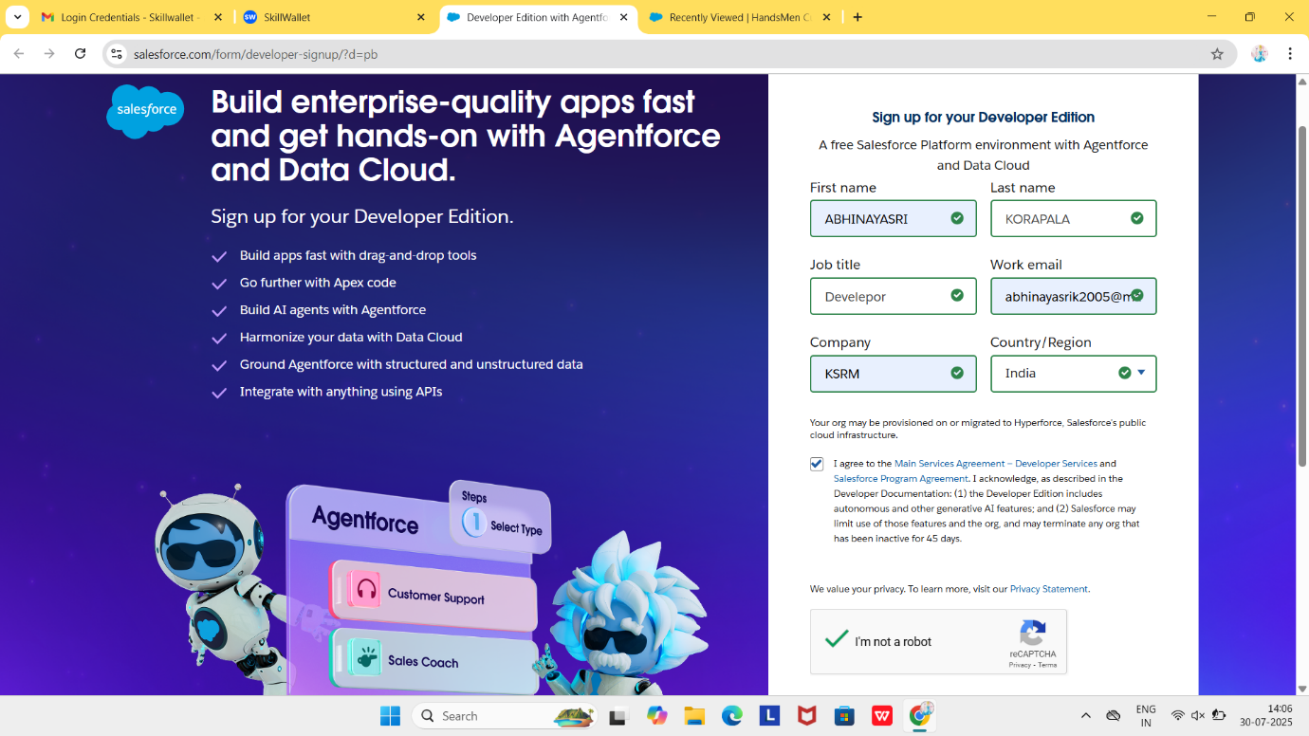

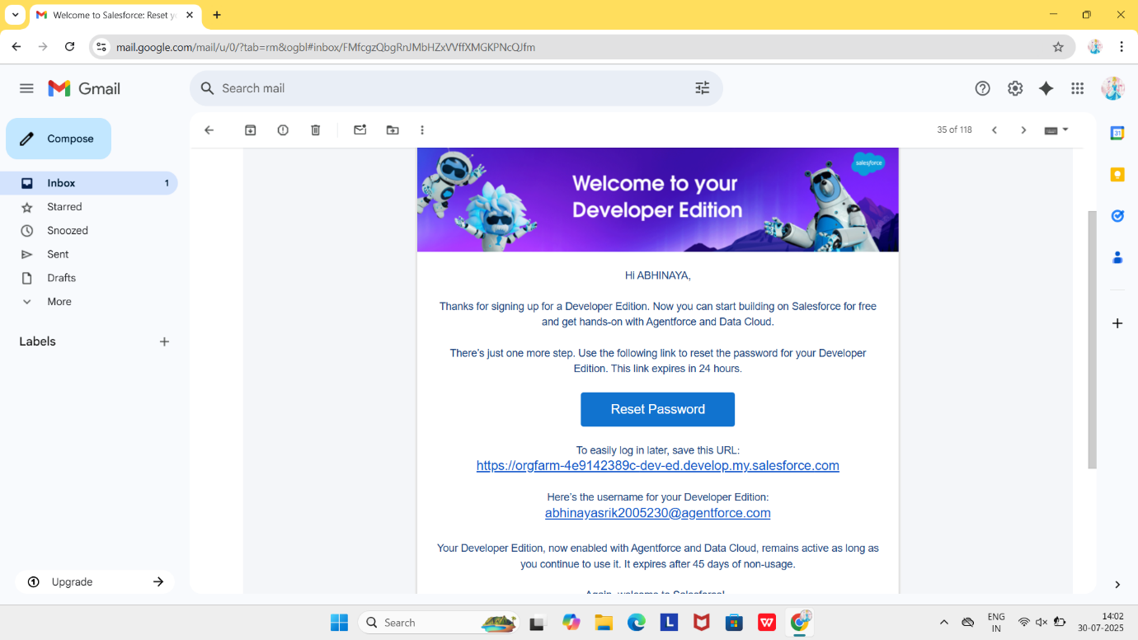

**2.Object Overview**

The object model serves as the backbone of the ClassicGent CRM system, representing real-world business entities through well-structured custom Salesforce objects. These objects encapsulate core business data and enable relationships, automation, and reporting capabilities within the CRM platform.

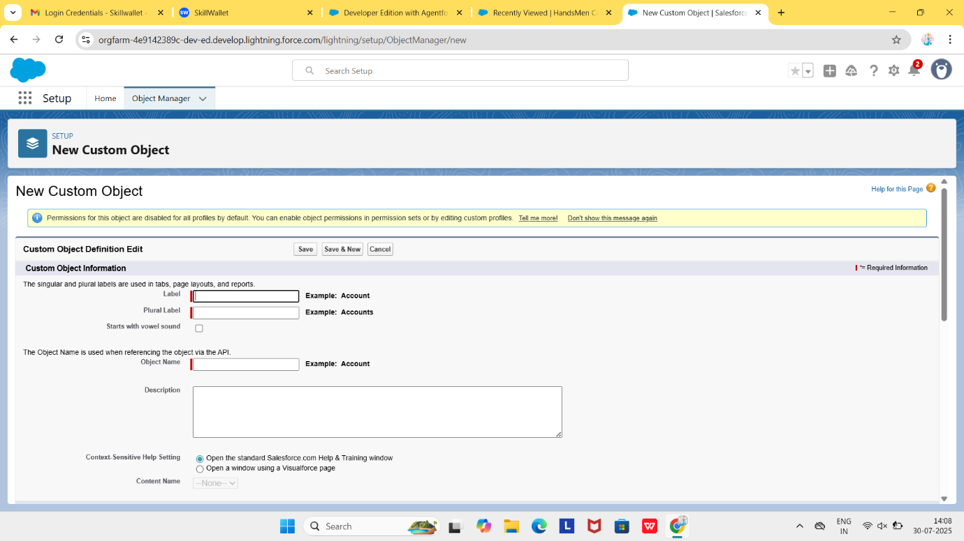

|  |  |
| --- | --- |
| **Object Name** | **Purpose** |
| HandsMen_Customer__c | Stores customer details including contact info and loyalty status |
| HandsMen_Product__c | Represents items available for sale |
| HandsMen_Order__c | Tracks purchase orders placed by customers |
| Inventory__c | Maintains product stock and availability |
| Marketing_Campaign__c | Captures campaign activities targeted at specific customers |

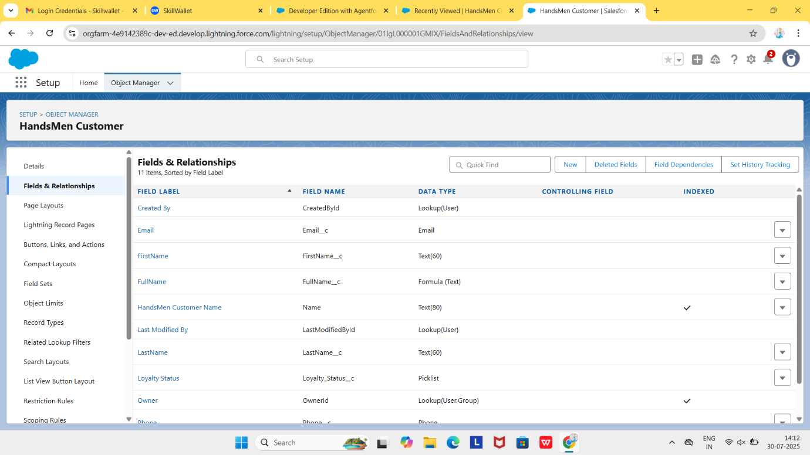

**3.Relationship Mapping**

To ensure data integrity and reflect business context, both Lookup and Master-Detail relationships were defined:

* **Lookup Relationships:**
  + **Order → Customer:** Customer__c field in HandsMen_Order__c links to a record in HandsMen_Customer__c
  + **Order → Product:** Product__c field in HandsMen_Order__c connects with HandsMen_Product__c
  + **Campaign → Customer:** Customer__c field in Marketing_Campaign__c connects to HandsMen_Customer__c
* **Master-Detail Relationship:**
  + **Inventory → Product:** Inventory__c maintains a master-detail relationship with HandsMen_Product__c
* **3. Input Validation Criteria**
* Validation rules were created to enforce business requirements and prevent invalid data entry:

|  |  |  |  |
| --- | --- | --- | --- |
| Object | Description | Condition (Logic) | Error Message |
| HandsMen_Customer__c | Email must use company domain | NOT(CONTAINS(Email__c, "@handsmenthreads.com")) | Please enter a valid @handsmenthreads.com email address. |
| HandsMen_Customer__c | Loyalty Status must not be blank | ISBLANK(Loyalty_Status__c) | Loyalty Status is required. |
| HandsMen_Order__c | Total amount must be greater than zero | Total_Amount__c <= 0 | Order amount must be greater than zero. |
| HandsMen_Order__c | Order status is required | ISBLANK(Status__c) | Please select the order status. |
| HandsMen_Product__c | Stock quantity cannot be negative | Stock_Quantity__c < 0 | Stock quantity cannot be less than 0. |
| Marketing_Campaign__c | Marketing type must be selected | ISBLANK(Campaign_Type__c) | Please select the campaign type. |

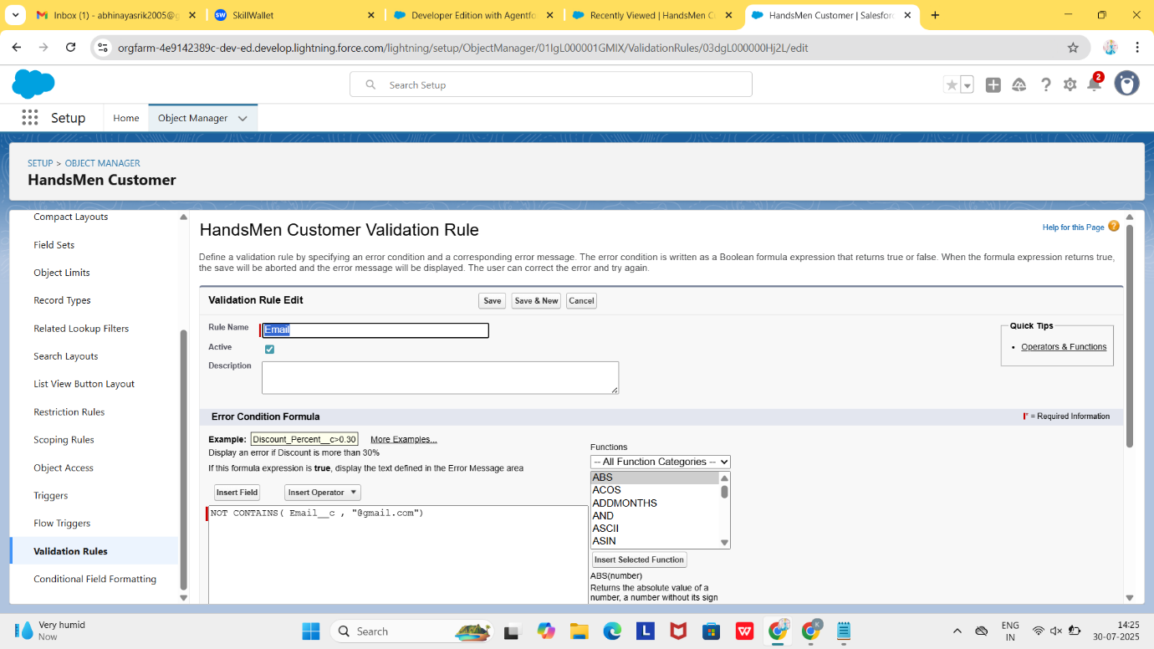

**4. Profile Configuration**

A custom profile named **Platform 1** was created by cloning the Standard User profile. It was adjusted to give full access to HandsMen_Product__c and Inventory__c, allowing CRUD operations.

**Role Hierarchy Setup:**

To manage data visibility:

* **Top Level:** CEO
  + Sales
  + Inventory
  + Marketing

This structure enables senior roles to access records created by subordinate roles

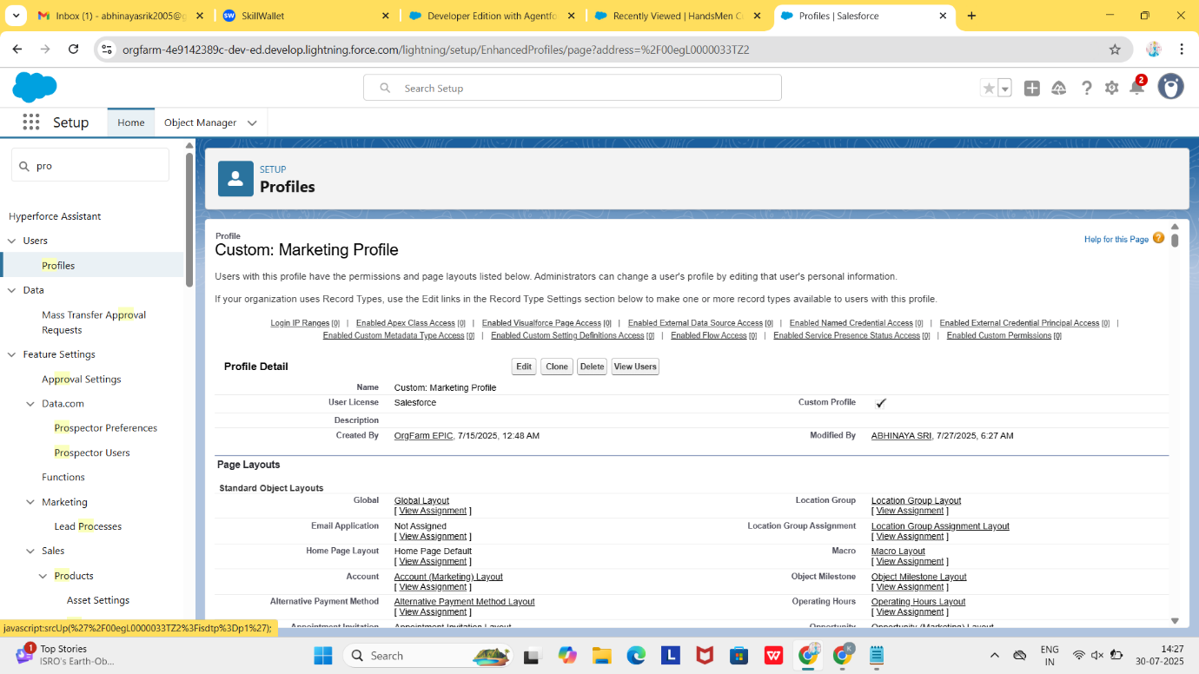

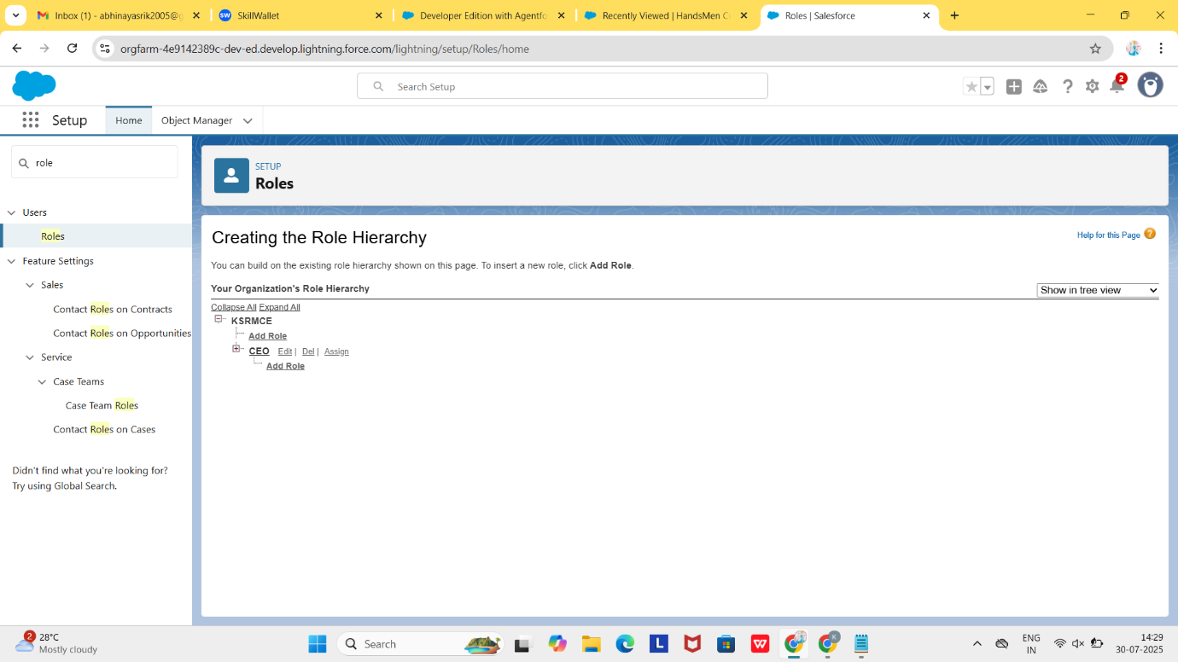

**5. Permission Set Allocation**

A permission set named **Permission_Platform_1** was designed to extend specific permissions:

* Read/Edit access to HandsMen_Customer__c and HandsMen_Order__c
* Assigned to users requiring cross-department access

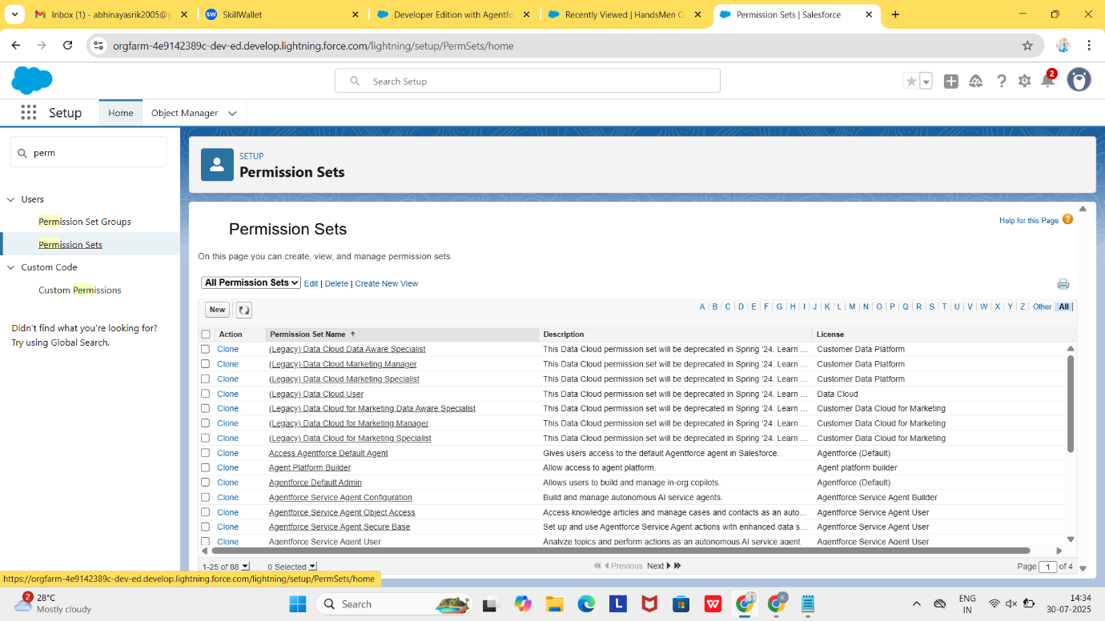

**6. Automated Customer Email**

Three email templates were created using Classic Email Templates:

* **Order Confirmation:** Sent to customers upon order confirmation
* **Low Stock Alert:** Sent to inventory manager when stock is low
* **Loyalty Program Email:** Triggered when a customer’s loyalty tier is upgraded

All templates are connected to Flow automation and Email Alerts.

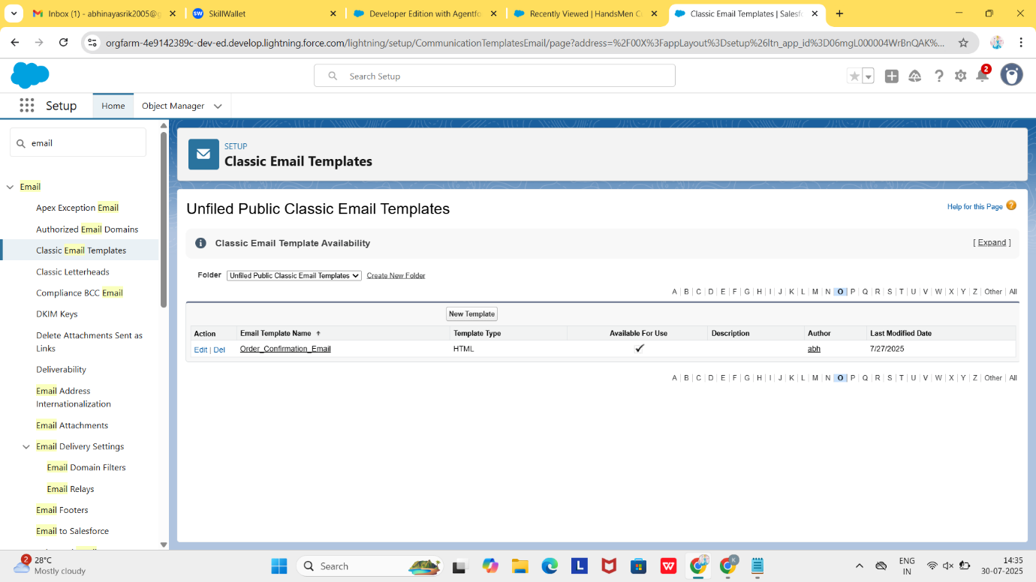

**7. Trigger Handlers & Apex Utilities**

* **Trigger Name:** OrderTrigger
  + Executes before insert/update on HandsMen_Order__c
* **Handler Class:** OrderTriggerHandler
  + Validates quantity and ensures business logic is enforced during order processing

**8. InventoryBatchJob Implementation**

* **Class Name:** InventoryBatchJob
  + Implements Database.Batchable and Schedulable
  + Scans for stock < 20 units and auto-adds 50 units
* **Execution:** Scheduled daily at midnight to maintain consistent inventory levels

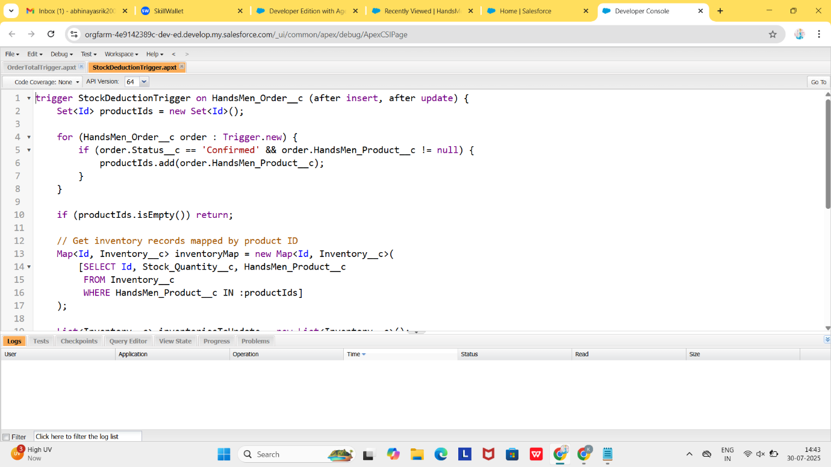

**Scope 3: Lightning Experience & User Interface Optimization**

**1. Lightning Workspace Configuration**

A custom Lightning App titled "ClassicGent CRM" was created using App Manager. The app features a tailored navigation bar that includes tabs for Customers, Orders, Products, Inventory, Campaigns, and Dashboards. This allowed users to quickly access key modules based on their roles.

The application was assigned to the System Administrator profile, ensuring maximum administrative control and testing visibility across modules.

**2. Interface Customization & Record Layouts**

Custom Tabs and Record Pages were built for each object using the Lightning App Builder. Fields, buttons, and related lists were strategically placed for optimal usability.

Dynamic Forms were enabled on major objects such as Orders and Products to show or hide fields based on user roles or record status. This enhanced both the clarity and user experience on record pages.

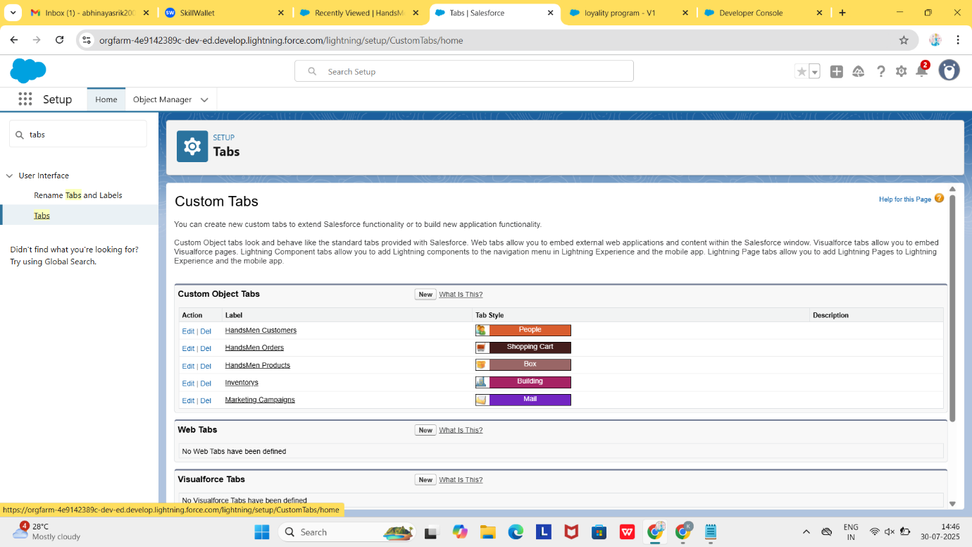

**3. User Roles & Simulation**

To mimic real-world department access and usage, two test users were created:

* Niklaus Mikaelson – assigned the Sales role
* Kol Mikaelson – assigned the Inventory role

Each user had:

* Platform 1 Profile
* Permission_Platform_1 Permission Set
* Role-based access per hierarchy

This setup verified that visibility rules and field-level access worked correctly**.**

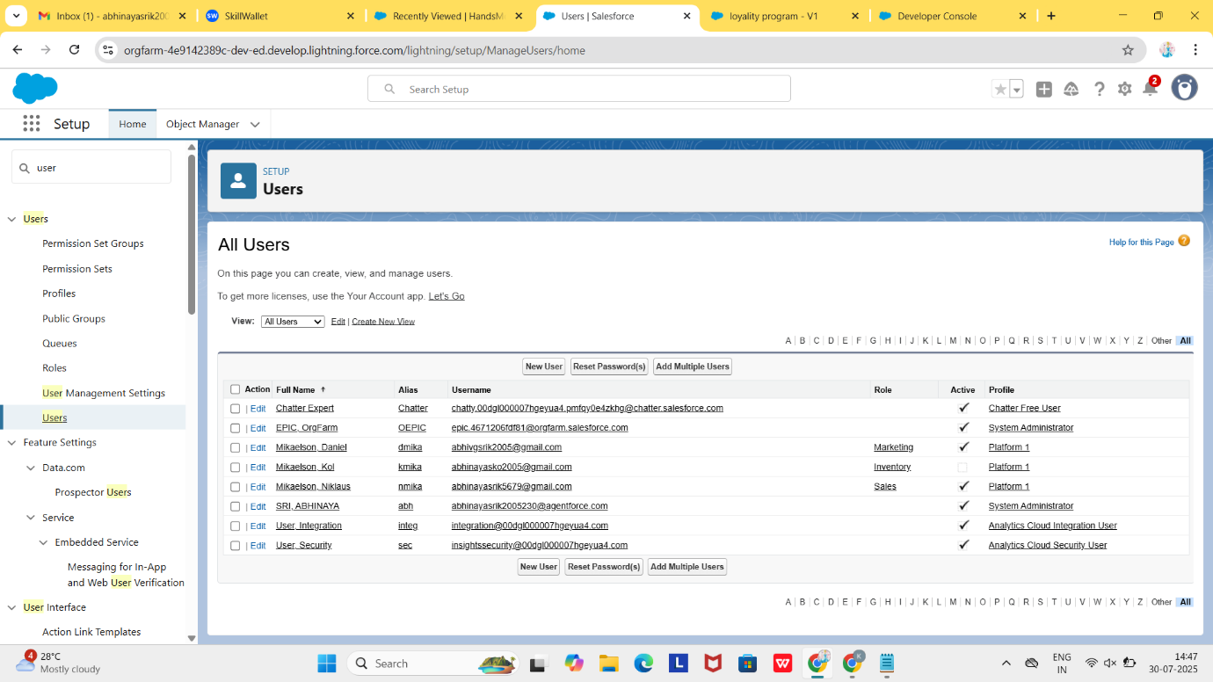

**4. Reports & Dashboards for Business Insights**

Custom reports were built to analyze:

* Order status distribution (Pending, Finalized, Dispatched)
* Inventory levels with low stock indicators
* Customer loyalty tier breakdown (Bronze, Silver, Gold)

Dashboards visualized these insights using charts and graphs, empowering business users to take quick action.

**5. Enhanced Record Pages**

Lightning Record Pages included:

* Quick Actions (e.g., Dispatch Order, Upgrade Tier)
* Related Lists (e.g., Order Items, Customer Notes)
* Embedded Reports for object-specific insights

This configuration resulted in a highly interactive and role-sensitive user interface across all user profiles.

**Scope 4: Data Migration, Quality & Security Controls**

**1. Data Upload Mechanisms**  
To replicate realistic testing scenarios, both bulk and single data entries were populated in the system:

* **Import Wizard**: Utilized for straightforward data sets such as HandsMen_Customer__c
* **Data Loader**: Employed for complex objects and large data volumes like Orders and Products

**2. Data Validation & Oversight Tools**

* **Field History Tracking** was activated for HandsMen_Order__c and Inventory__c to monitor changes in order status and inventory quantity
* **Duplicate Management** used rules based on Mobile Number and Email to avoid repeated customer records
* **Matching Algorithms** ensured new records were aligned with existing data to minimize duplication during data loads

**3. Security Settings: Roles, Profiles & Access Control**

* **Platform 1 Profile** granted baseline object access
* **Organizational Role Structure**:
  + Executive Director
    - Sales Representatives
    - Inventory Team
    - Customer Care Agents
* **Permission Sets**: Provided extended permissions for HandsMen_Order__c and HandsMen_Customer__c beyond standard profiles
* **Sharing Settings**: Configured as **Private** in production with defined sharing rules to support cross-team collaboration

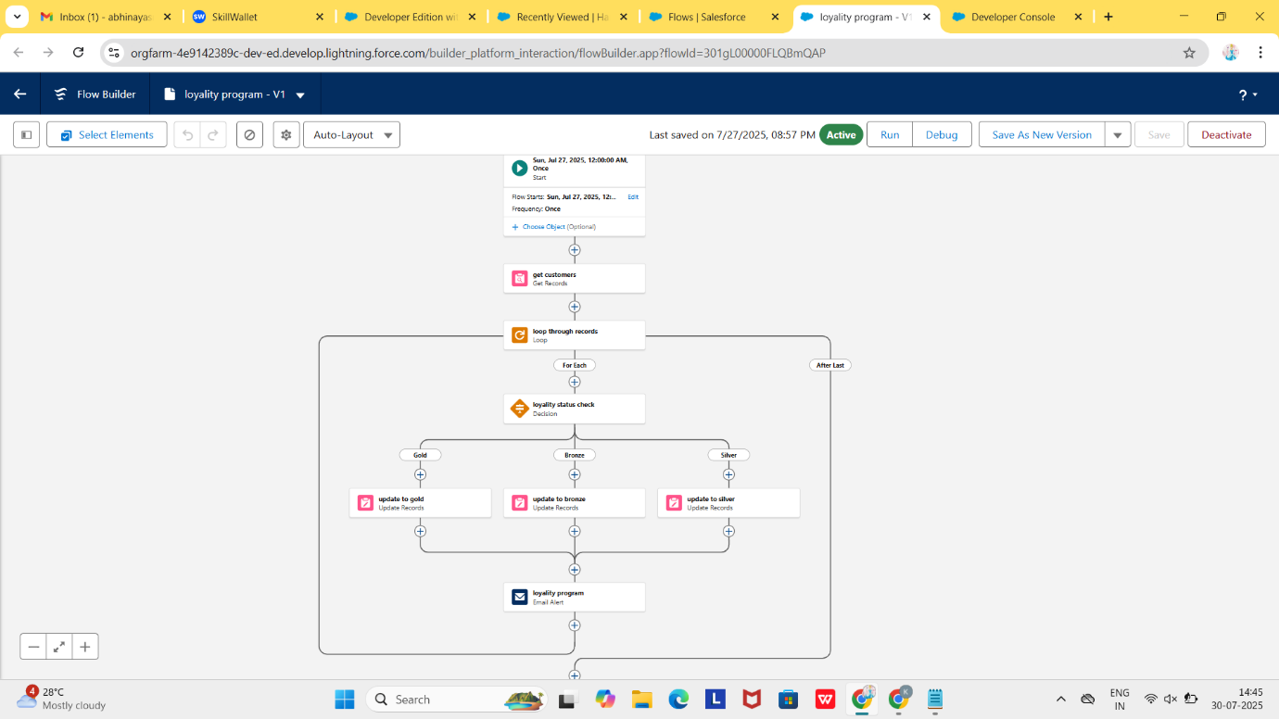

**4. Flow Automation Testing**

* **Loyalty Tier Automation**: Automatically updates customer level (e.g., Bronze → Silver → Gold) based on activity
* **Stock Alert Flow**: Sends automated emails to warehouse staff when inventory falls below defined levels
* **Order Completion Notification**: Dispatches a confirmation email when an order reaches the 'Finalized' status

**5. Apex Unit Testing & Code Coverage Metrics**

* Comprehensive test classes were created for all custom triggers and batch processes
* Testing scenarios included boundary cases, core functionality, and data validation checks
* Salesforce’s minimum requirement of 75% code coverage was surpassed, achieving over **85% actual coverage**

**Scope 5: Testing, Data Accuracy & Future Growth**

**1. Testing and Validation Approach**

Each setup and automation was rigorously tested through dummy data and real-world usage scenarios. Key validations included:

* Processing both valid and invalid order attempts
* Verifying automatic loyalty level upgrades
* Triggering low stock alerts through inventory simulations
* Confirming access restrictions for non-admin users.

**2.** **Data Quality & Validation Controls**

Advanced Salesforce features were leveraged to maintain accurate, clean records:  
• **Field Tracking Logs**  
Activated on essential objects like HandsMen_Order__c and Inventory__c to track changes in key fields like order status or inventory levels.  
• **Duplicate Prevention Rules**

* **Duplicate Rules**: Applied to HandsMen Customer using the Email field to block duplicate records.
* **Matching Rules**: Helped detect existing records during data uploads or manual creation to prevent redundancy.

**3. Planned Feature Extensions**

Recommended improvements for upcoming phases include:

* Virtual Assistant: AI-powered chatbot (Einstein Bot or third-party) to handle customer queries instantly
* Personalized Suggestions: Displaying relevant products using past purchase data
* Predictive Dashboards: Integrating Einstein Analytics to forecast trends in sales and customer behavior
* Mobile UI Enhancements: Mobile-friendly interface with real-time alerts for stock, order status, and updates
* Automated Reviews: Feedback requests triggered post-purchase via Flow with embedded Typeform or Google Form
* Geo-Based Access: Enable region-wise CRM permissions for distributed teams and branches

These planned updates aim to enhance user experience, expand automation, and support future scalability of the HandsMen Threads CRM system.

**Conclusion**

The implementation of the Salesforce CRM solution for HandsMen Threads marks a transformative step in modernizing and optimizing the brand’s business operations. By integrating customer management, order processing, inventory tracking, and marketing automation into a single unified platform, the system has streamlined workflows, improved data accuracy, and enhanced user experiences across departments.

The project successfully utilized Salesforce tools such as Flows, Apex, Lightning Web Components, and Email Alerts, combined with robust custom object models, role-based access control, and data validation rules to ensure a scalable and secure solution. Key business insights were made accessible through tailored dashboards and reports, empowering decision-makers with real-time visibility.

Rigorous testing ensured system integrity and reliability, exceeding Salesforce's code coverage requirements. Post-implementation planning outlines clear paths for future growth, including AI-powered features, advanced analytics with Salesforce Einstein, intelligent recommendations, and territory-based access—positioning the CRM for continuous evolution and responsiveness to business needs.

Ultimately, this project has not only digitized HandsMen Threads’ customer relationship management but has laid the groundwork for a data-driven, customer-centric, and agile enterprise, ready to adapt and grow in a competitive digital landscape.